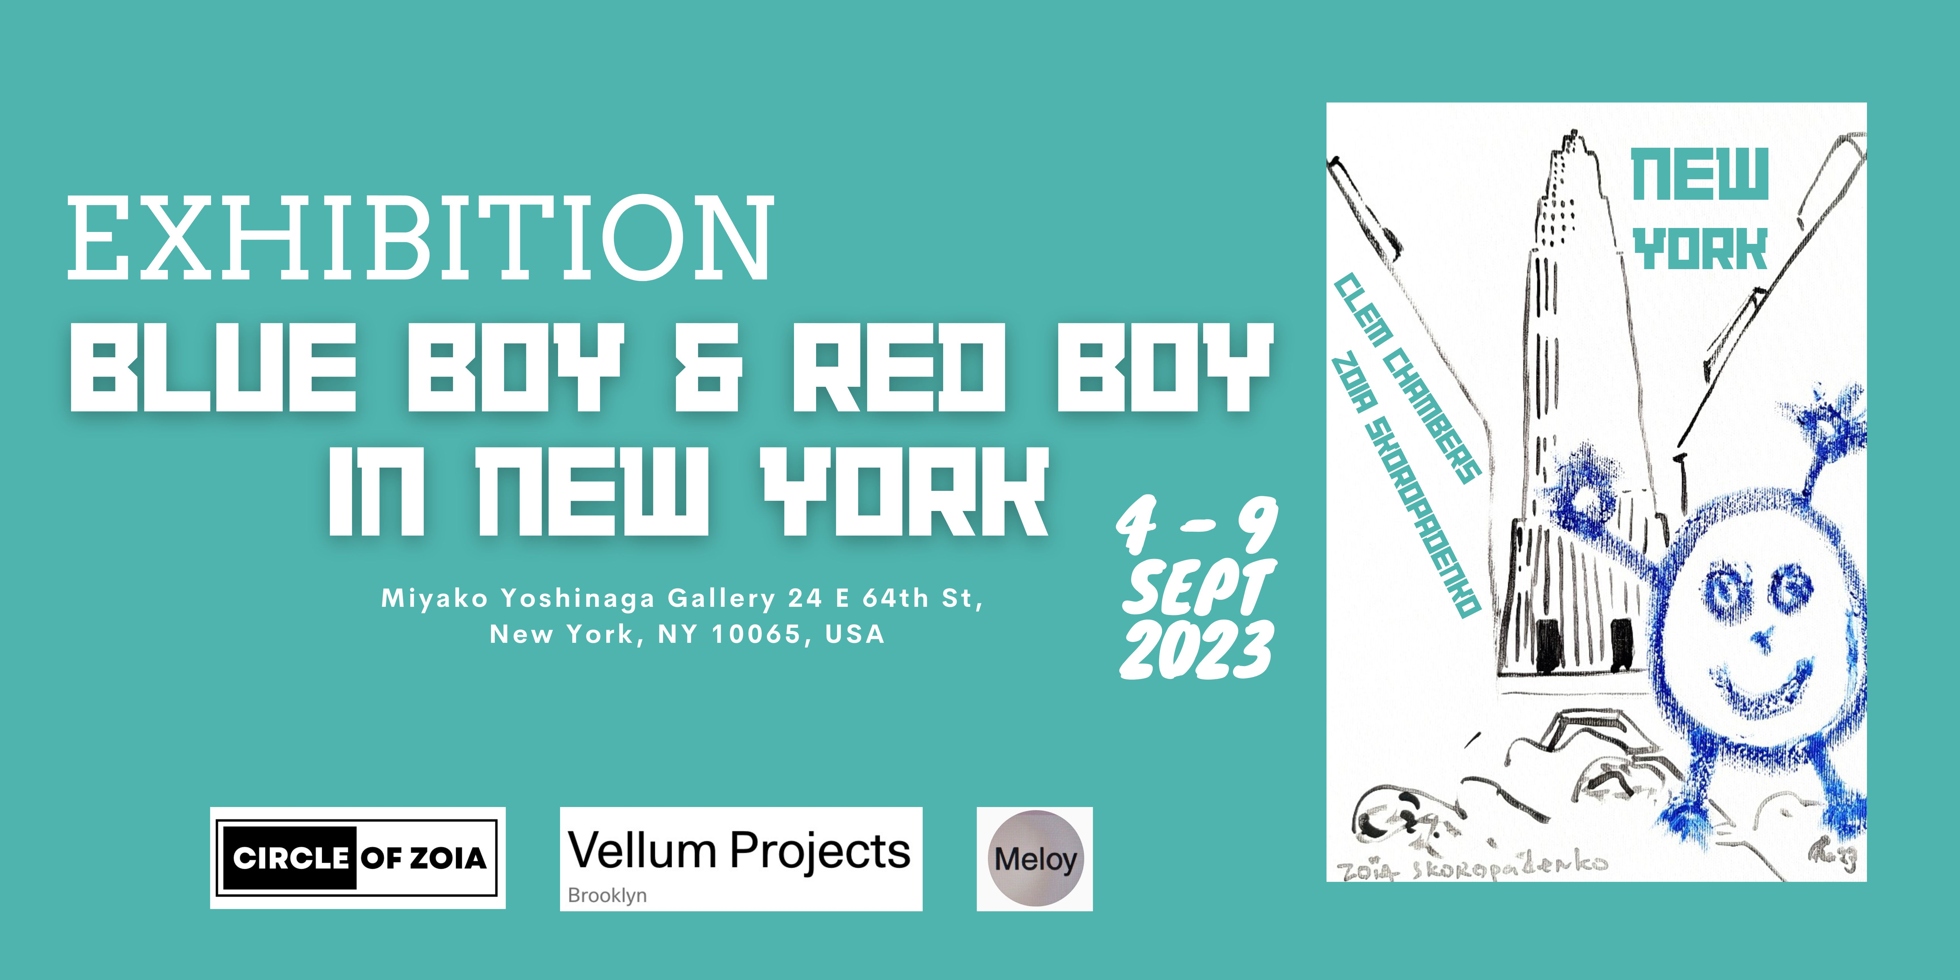
Press-Release:

"Blue Boy & Red Boy: An Enchanting Contemporary Art Exhibition Unveiling the Heart of New York City through the Eyes of your inner child”

Following resounding triumphs in Paris and Monaco, a visionary contemporary art exhibition crafted by two renowned European artists is set to dazzle the cultural epicenter of New York City. Riding the wave of their previous successes, this exceptional showcase promises to redefine the artistic landscape and captivate audiences across the metropolis. The anticipation mounts as New York eagerly awaits the unveiling of an unparalleled artistic experience that embodies the essence of innovation and creativity.

Source: The Meloy Art | Monday 28, Aug 2023

NY, USA, Aug. 28, 2023 —
In a celebration of unadulterated wonder and artistic brilliance, the much-anticipated exhibition, "Blue Boy and Red Boy," emerges as the captivating brainchild of contemporary artists Zoia Skoropadenko and Clem Chambers. Drawing inspiration from their cherished childhood emotions and the exhilaration of a first encounter with New York, these visionary artists weave a mesmerizing tapestry of innocence and enchantment. As patrons embark on a visual odyssey, Zoia and Clem's evocative artistry pays homage to the timeless allure of NY, transporting audiences to a realm where dreams and reality effortlessly intertwine.

Skoropadenko exclaims, "This is my second time in NY, and I am beyond thrilled! The city is an absolute legend, bursting with character that I simply relish capturing in my paintings. It's an exhilarating experience, and I thoroughly enjoy infusing my artwork with the very essence of this iconic metropolis.”

“What sets titled "Blue Boy and Red Boy" apart from other art exhibitions is its fun. The juxtaposition of childlike figures and recognisable NY landmarks is joyous. Red Boy and Blue Boy are archetypes we all recognise with their round faces and exaggerated features, giving them a playful and almost cartoonish appearance. Against this backdrop, Zoia Skoropadenko paints some of NY’s most iconic landmarks, such as the Statue of Liberty, Rockefeller Center, Chrysler Building, Central park etc.
The exhibition is particularly aimed at NY art collectors and is held in Manhattain trendy Upper East Side neighbourhood in a gallery right beside Central Park and Park Avenue Armory. Skoropadenko and Chambers hope their playful and colorful artwork will appeal to everyone, offering them a sense of nostalgia and wonder that is both lighthearted and meaningful.
"I wanted to create something that would speak to people's inner child," Clem Chambers said. "There is a joy and innocence that we often lose as we grow older, and I wanted to capture that feeling with my art.” Zoia Skoropadenko added “I hope that our works will bring a smile to people's faces and remind them of the magic of Paris and the ‘joie de vie’ of being here.”
"Blue Boy and Red Boy" will run from September 4 to September 9th at the MIYAKO YOSHINAGA GALLERY 24 East 64th Street, New York, NY 10065 USA
Admission is free, and all are welcome to attend. Don't miss your chance to experience this unique and captivating art exhibition.

Exhibition is presented by The Meloy Art and Circle of Zoia.
Notes for editors
If you are interested in interviewing artists. They are available by skype, zoom, what’s up, telephone, etc @zoiaskoropadenko or zoia.skoropadenko@gmail.com or +33601146560

Location Miyako Yoshinaga Gallery. 24E 64th St, NY 10065
Opening By invitation on 5th of September from 6pm
Opening Hours 10am-6pm from Monday 4 September to Saturday 9 September.
Admission Free
Getting there The closest subway station is 5 Av/59 St
The closest bus stations is Madison Av/E 63 St Buses M2, M3, M4
Twitter @Zoiaskoropadenk, #themeloy #circleofzoia #blueboyredboy
Instagram @zoiaskoropadenko @themeloy.art #circleofzoia #blueboyredboy
Facebook zoiaskoropadenkostudio
Phone +33601146560 | +447971629707
Email cc@themeloy.art | zoia.skoropadenko@gmail.com
Website www.themeloy.art | www.zoiaskoropadenko.com
Visuals HD and WORD, PDF: www.themeloy.art/bbrbinny

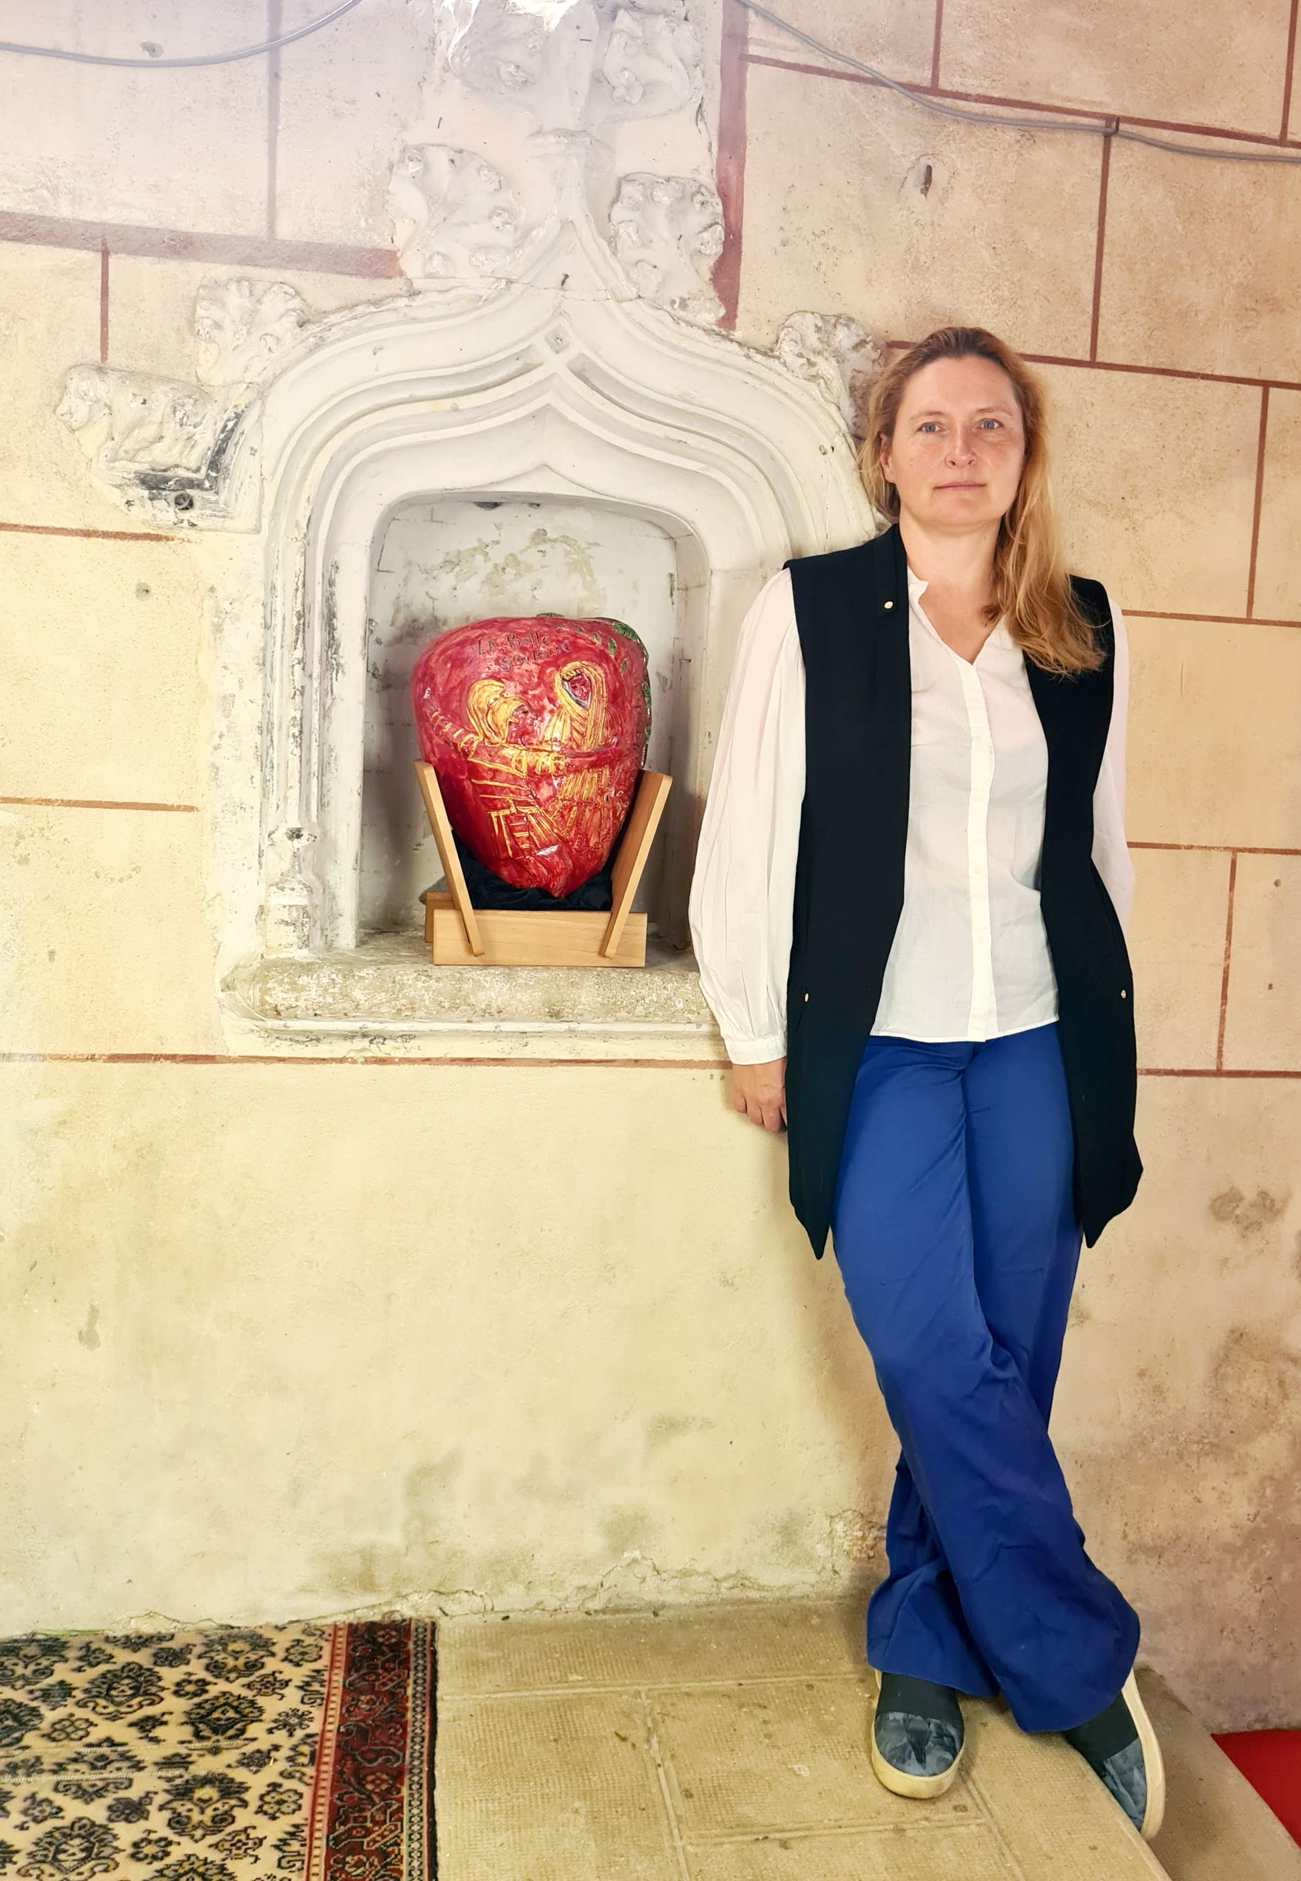
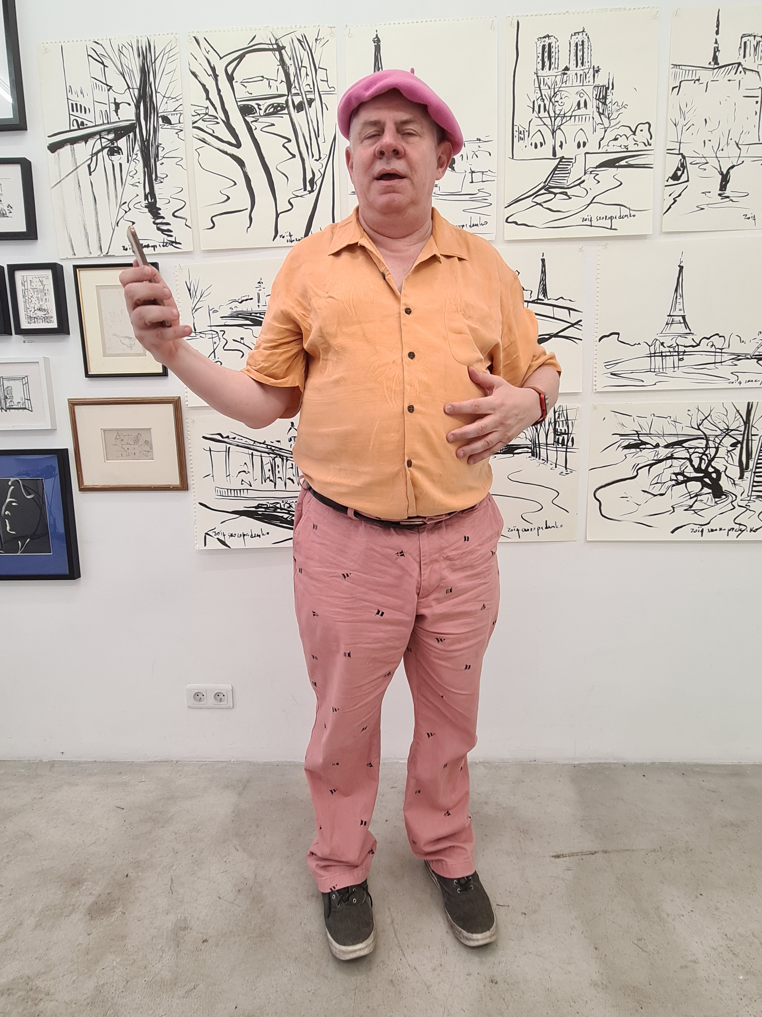
ABOUT ARTISTS
Zoia SKOROPADENKO is a multidisciplinary artist, curator, art collector who lives and works in Monaco.

Her TORSO series are highly regarded and adored by art professionals and art collectors around the world. The series were exhibited in Council of Europe, London Stock exchange, Toronto and Tokyo Art Fair as a special guest. Her sculpture “The Hope” was inaugurated in Fukushima (Japan) and in Chernobyl National Museum in Kiev.
For last 20 years of her life in Monaco she integrated into the artistic world of the Côte d'Azur, where she met leading artists such as Armand, Ernst Fuchs, Emma de Sigaldi, Jean-Michel Follon, Robert Rauschenberg, Sasha Sosno and others. She then worked in the studio of the American mosaicist Nall Hollis.
In 2009, Skoropadenko launched La Vitrine, a contemporary art micro-gallery in Monaco, where she exhibits her work and provides a platform for young talents as well as established artists. Zoia Skoropadenko is now a member of the National Arts Committee of the Principality of Monaco, where she enjoys the status of a professional-painter.
Since 2021 together with virtual art gallery The Meloy Art she organises series of exhibitions in Paris which gathering famous artists from around the world together with private art collectors who show the art pieces by grand masters from the past from their collections.
Since 2021 The Circle of Zoia hold in Paris such exhibitions as: “Monaco VS Vallauris”, “The Best Ukrainian Art” in time fo FIAC, “The Great Shots” in time of Paris Photo Art Fair, “Oh ceramics” in time of Deco OFF 2022, “Extraordinary Drawings” during Salon de dessin, “Zoia’s Ark”, Exhibition 99,9 and “With Love to Notre Dame”.
Clem CHAMBERS is a Monaco based UK contemporary artist known by his series of oil abstract mathematical paintings “Fractals”. Fractals are infinitely complex patterns that are self-similar across different scales. They are created by repeating a simple process over and over in an ongoing feedback loop. The “Fractal theory” was discovered and explored by late French Professor Benoit Mandelbrot; who developed a new class of mathematical objects: fractal objects or fractals. Chambers and Mandelbrot met in 2003, and in 2004, Clem started series of oil abstract paintings using Mandelbrot’s theories. “Fractals” were first exhibtied in London in 2006. The series has also been shown in Japan, US, UK, Monaco and France.
Zoia Skoropadenko with her ceramic sculpture. Selfportrait.
Photo courtesy of the artist
Clem Chambers by Zoia Skoropadenko.
Photo credit of the artist
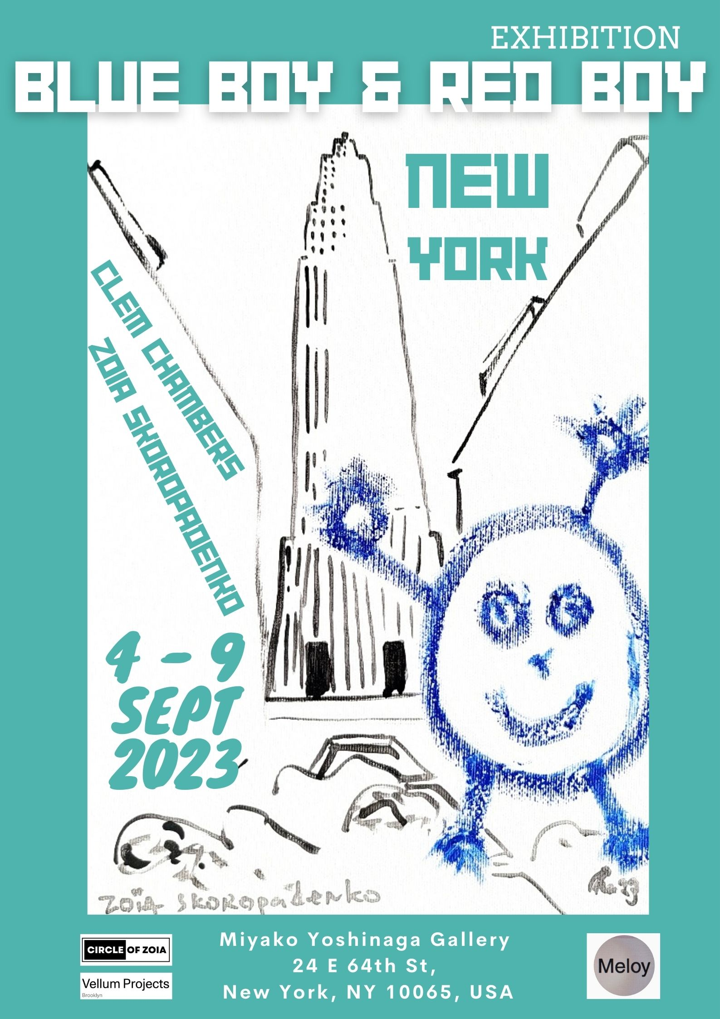
VISUALS FOR EDITORS:
Official poster of exhibition.
In the attachment in JPEG and PDF

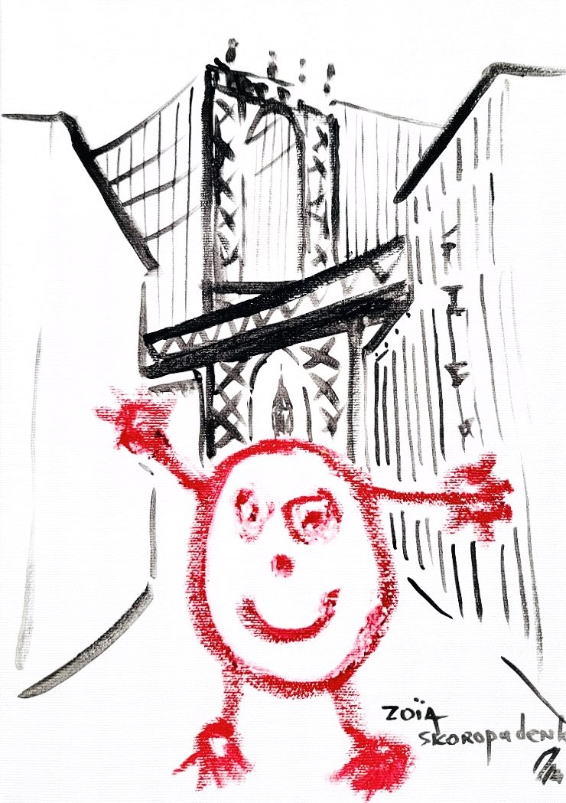
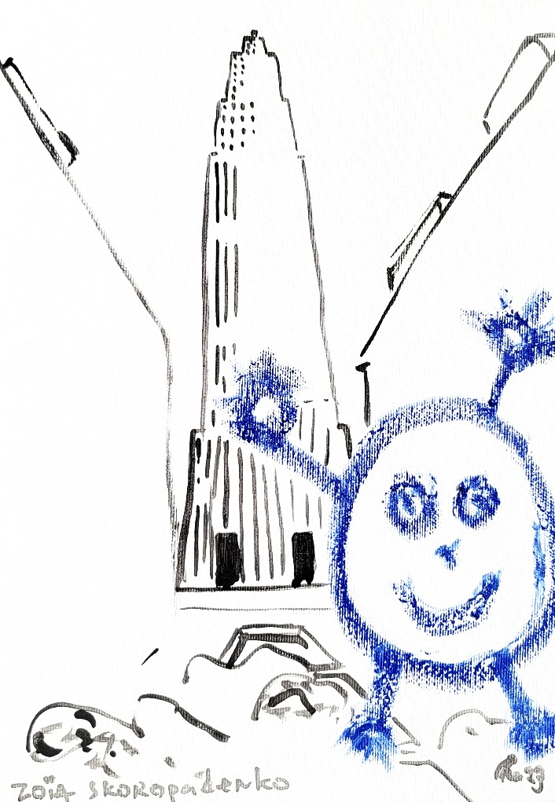
Red Boy in New York. by Clem Chambers and Zoia Skoropadenko. Oil on canvas. 2023. Courtesy of the artists. Photo by Zoia Skoropadenko
Blue Boy in New York. by Clem Chambers and Zoia Skoropadenko. Oil on canvas. 2023. Courtesy of the artists. Photo by Zoia Skoropadenko

